WINDOWS APPLICATION TESTING ON UFT (SAMPLES FLIGHT APPLICATION)
- Open UFT (UNIFIED FUNCTIONAL TESTING)
- Create a New Test
- Record and Run settings
- Go the Windows application(Note:- other option should be record and run on (1st option) should be selected)
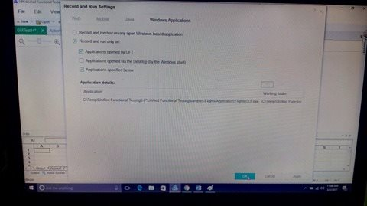

- Resources-> Object Repository Manager
- Select the object from the object repository (take the GUI application and select on the Username)
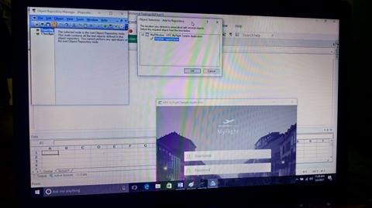

- Hit the Record Button and steps are followed

- Give username and password
Username-john
Password-HP
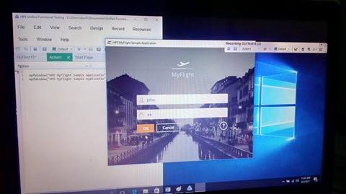

- Next page will be flight reservation
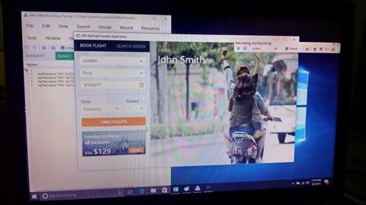

- Search the flights

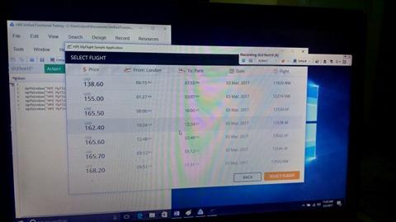

- After selecting flight, give the passenger name and select order and order completed

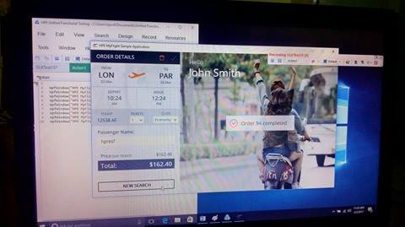

- Here the VBScript which is the automatically created on ViewEditor when recording.

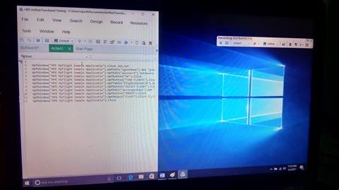

- Click the RUN Button and test case successfully run.

